|  |
| --- |
|  |
| 新概念 3 册 |
| Lesson24 |

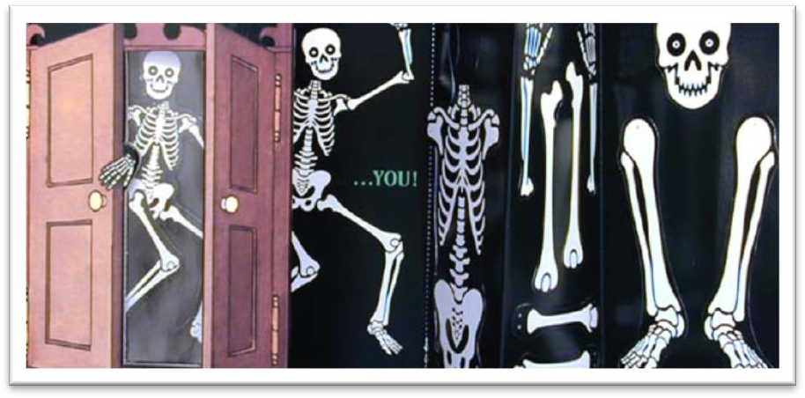Lesson 24 A skeleton in the cupboard

**seemingly ['si:mɪŋli] adv. 看似，表面上**

Running a mile under 4 minutes was a seemingly impossible task. on the surface

Mike was very pleasant on the surface, but he had a nasty temper.

seem / appear to do

running a mile under 4 minutes, an impossible task

Running a mile under 4 minutes seemed / appeared to be an impossible task. Mike, very pleasant, but he had a nasty temper.

Mike seemed / appeared to be very pleasant, but he had a nasty temper.

It seem / appear that …

running a mile under 4 minutes, an impossible task

It seemed / appeared that running a mile under 4 minutes was an impossible task. Mike, very pleasant, but he had a nasty temper.

It seemed / appeared that Mike was very pleasant, but he had a nasty temper.

**seeming / superficial**

In spite of his seeming / superficial friendship, he gave me no help.

respectable [rɪ'spektəbl] adj. 体面的，正派的

a respectable citizen a respectable family

He is a bit too respectable for my taste.

respected

a highly respected surgeon

respectful

You should be more respectful of other people’s points of view.

respective

After the party we all went back to our respective homes.

respecting concerning regarding

造句：在这篇有关科学家的文章中，作者特别尊重那些不但是体面正派的公民，而且在各自的领域中都深受敬仰的专家。

In the article respecting scientists, the writer is particularly respectful of those who are not only respectable citizens, but respected experts in their respective fields.

conceal [kən'si:l]

**v. 隐瞒，隐藏**conceal … from … hide … from …

reveal … to … disclose … to … expose … to … **fiction ['fɪkʃn]**

n. 小说

novel ➔ fiction poem ➔ poetry myth ➔ mythology scene ➔ scenery

jewel ➔ jewellery (jewelry) machine ➔ machinery

leaf ➔ foliage

table / chair … ➔ furniture pen / pencil … ➔ stationery

trunk / suitcase … ➔ luggage / baggage

unpack [ʌn'pæk]

**v. （从箱中）取出**pack ➔ unpack load ➔ unload lock ➔ unlock fasten ➔ unfasten screw ➔ unscrew **petrify ['petrɪfaɪ]**

v. 使……惊呆

Medusa

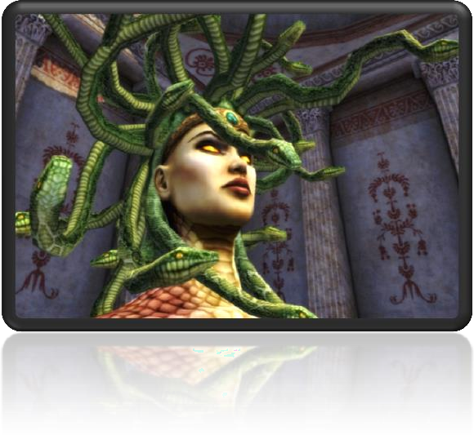

horrify terrify

**frighten scare**

be frightened / scared / afraid of …

Many girls are frightened / scared / afraid of cockroaches.

dangle ['dæŋgl]

**v. 悬挂（并摆动）**

A hanger dangled on the rope.

suspend hang

sway swing

unsympathetic [ʌnsɪmpə'θetɪk]

**adj. 不同情的，无动于衷的**

unsympathetic sympathetic

pathetic apathetic

sympathize sympathize with …

**sympathy** show sympathy win sympathy

out of sympathy

Out of sympathy, I gave the beggar some change. a skeleton in the cupboard

a skeleton in the closet a family skeleton

wash one’s dirty linen air one’s dirty laundry

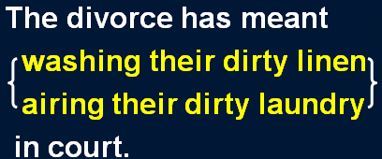

We often read in novels how a seemingly respectable person or family has some terrible secret

*which has been concealed from strangers for years*. Some person at the door is asking to see you.

… which has been hidden from strangers for years.

造句：我们常常在报纸上会读到一个表面上很体面的名人 (personality) 是如何因为偷税漏税 (tax evasion) 而被起诉的 (be charged with …)，而这种行为他们对公众 (the public) 隐瞒了很多年。

We often read in newspapers how a seemingly respectable personality was charged with tax evasion which had been concealed from the public for years.

saying: proverb / adage 谚语；格言

The Chinese language possesses a vivid saying ‘God favors the diligent’. As an old Chinese saying goes, ‘God favors the diligent’.

At the climax of the story, …

造句：这个道貌岸然的官员 (official) 贪污 (embezzle) 了巨额公款 (enormous government funds)。现在这个秘密已经公开了，他也名声扫地。

The seemingly respectable official embezzled enormous government funds. Now the secret becomes known and his reputation is ruined.

The reader's hair stands on end *when he reads in the final pages of the novel that the heroine, a dear old lady who had always been so kind to everybody, had, in her youth, poisoned every one of her five husbands*.

make one’s hair stand on end

Wait until I tell you about the murder—it'll make your hair stand on end.

**make one’s blood run cold** frighten / scare the life out of sb. frighten / scare the hell out of sb. Lynette? Honey? Are you home? Three months.

God, you scared the hell out of me!

in one’s youth

**in one’s childhood in one’s early years in one’s adolescence in one’s middle age in one’s old age**

造句：当我在电视剧 (TV drama) 的最后一集 (the final episode) 看到主人公，那个对每个人都很友善的体面的 (respectable) 律师，原来竟是个 (turn out to be) 残忍的谋杀犯时 (a savage murderer)，被吓得毛骨悚然。

My hair stood on end when I watched in the final episode of the TV drama that the hero, a respectable lawyer who had been so kind to everybody, turned out to be a savage murderer. It is all very well for such things to occur in fiction, but in real life it is barely credible.

It is all very well for … to …, but … it is barely … .

造句：你在家里穿睡衣 (pajamas) 是无可厚非的，但是在公共场合就不太体面了。

It is all very well for you to wear pajamas in your own home, but in public it is barely respectable. *To varying degrees*, we all have secrets which we do not want even our closest friends to learn, but few of us have skeletons in the cupboard.

to varying degrees

Racism still exists to varying degrees.

The water of rivers, lakes and reservoirs in China was universally polluted to varying degrees. closest friend intimate friend

bosom friend

fair-weather friend pen pal / friend internet pal / friend

不在同一层次上的双重定语从句

第一个定语从句修饰前面的名词或短语，第二个定语从句修饰“名词或短语+第一个定语从句”两个定语从句之间没有并列连词连接。第一个定语从句的关系词(一般是关系代词作宾语)可省略。

The only person *I know* who has a skeleton in the cupboard is George Carlton, and he is very proud of the fact.

You’re the only person *I’ve ever met* who could do it.

He’s the best man *I can find* who can mend it within an hour.

be proud of … take pride in …

**pride oneself on …**

Much as we may pride ourselves on our good taste, we are no longer free to choose the things we want, for advertising exerts a subtle influence on us.

instead of doing …, however, …

Instead of becoming a doctor, however, Lu Xun became China’s foremost modern writer of satirical essays.

transferred epithet 移就

a sad letter

a lonely night

平林漠漠烟如织寒山一带伤心碧自春来、

惨绿愁红，

芳心是事可可。

show = lead 领某人去某地

Aleko denied taking it and led Dimitri into his back yard. unpack my things / belongings

unpack my suitcase

She came home *sick*. Only the good die *young*.

形容词作主语补足语

Inevitably you arrive at your destination *almost exhausted*.

However you decide to spend your time, one thing is certain: you will arrive at your destination

*fresh and uncrumpled*.

The sudden movement of the door made it sway slightly and it gave me the impression that it was about to leap out at me.

give sb. the impression that … have / get the impression that … be under the impression that ...

… and I had / got the impression that it was about to leap out …

… and I was under the impression that it was about to leap out …

Though the crew were at first under the impression that the lost ship had been found, the contents of the chest proved them wrong.

be about to do …

**be on the point of doing …**

It was on the point of leaping out at me.

leap jump bounce

That’s one small step for a man, one giant leap for mankind.

— Neil Armstrong

by leaps and bounds: very quickly

He's growing very quickly.

He's the tallest of three boys.

He can jump high.

He has to leave today at there.

M: Your little nephew is growing by leaps and bounds. W: Yes. He must be at least three feet tall already.

Q: What do the speakers say about the woman’s nephew? Answer: (A) He's growing very quickly.

But George didn’t sympathize with me.

But George had / showed no sympathy for me.

Don’t act as if you were the only pebble on the beach. medical staff

medical ethics